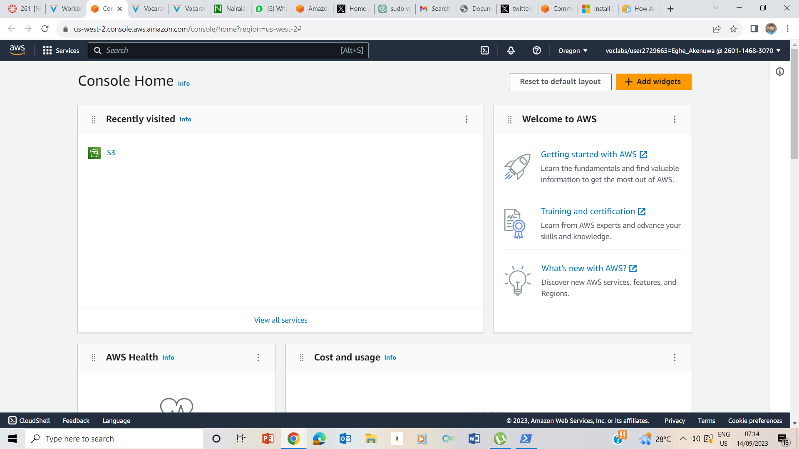

**Task 1: Investigate the customer's environment**

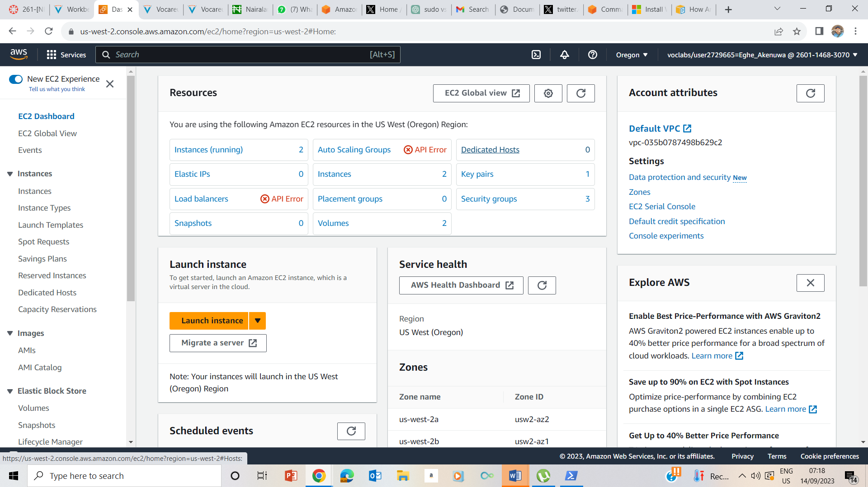

**Ec2 Dashboard**

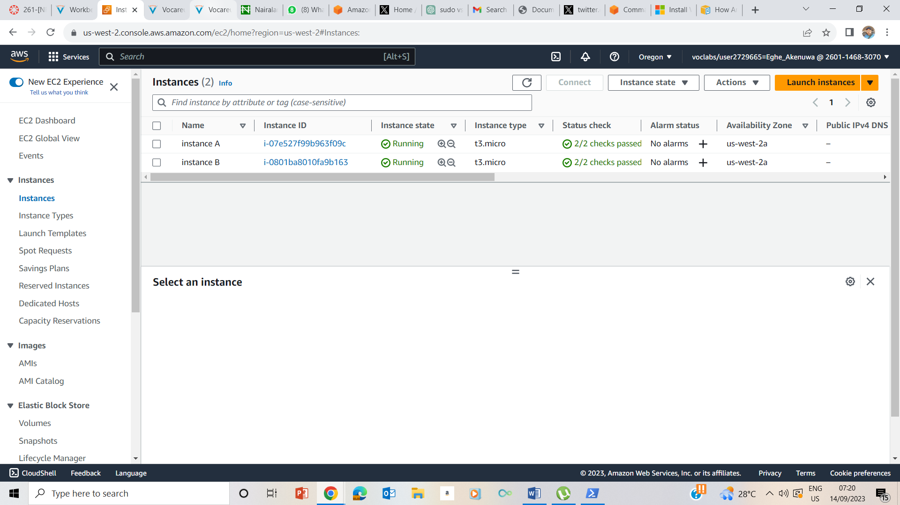

**EC2 Instances.**

Private IPV4 - 10.0.10.121

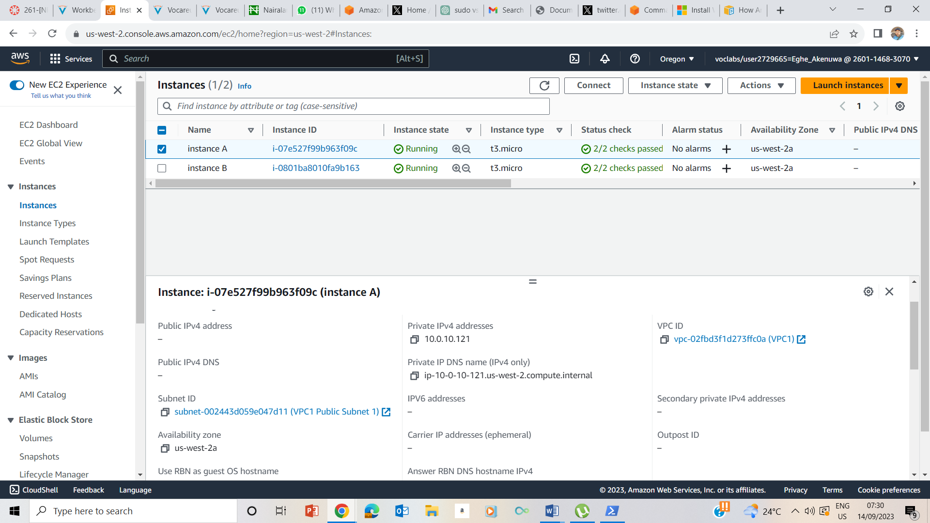

**Amazon EC2 instance A working information with private ip address and no public ip address**

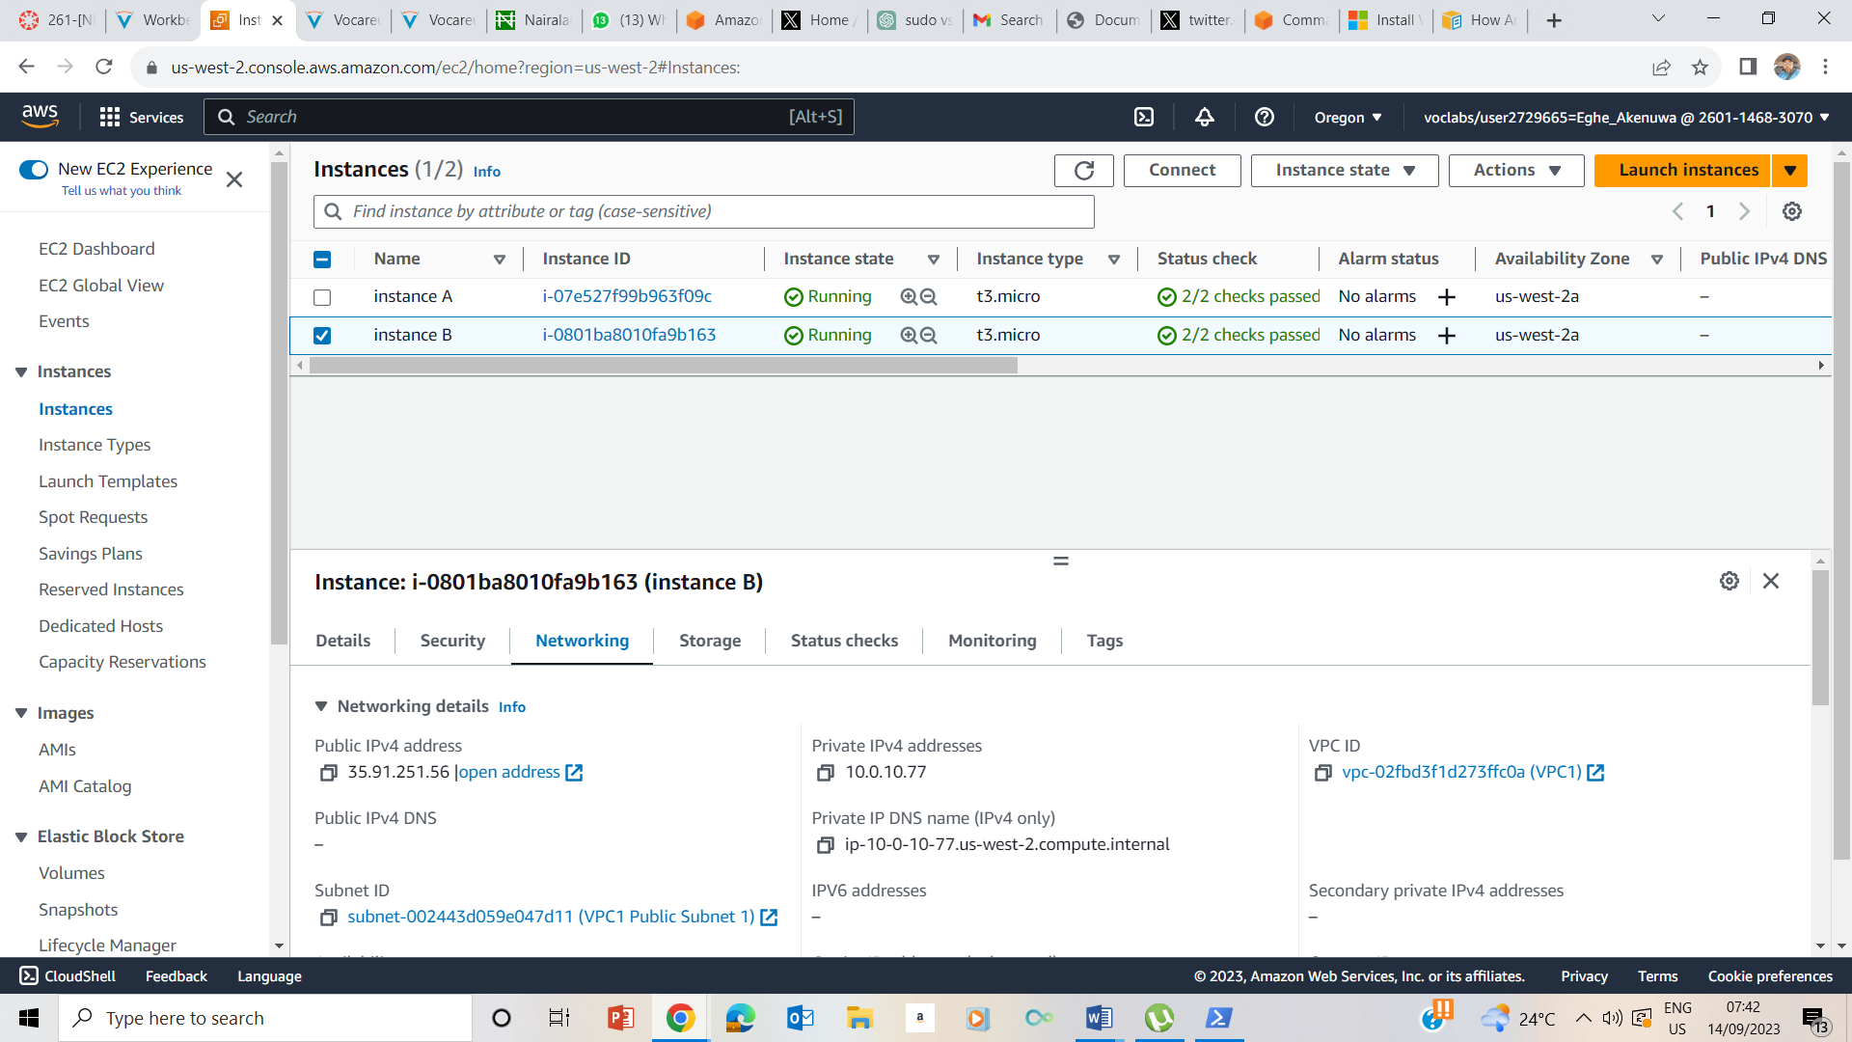

**Ec2 instance B working information with private ip address 10.0.10.77 and public ip address 35.91.251.56**

**Instance A has no public ip address while Instance B has both private and public ip addresses**

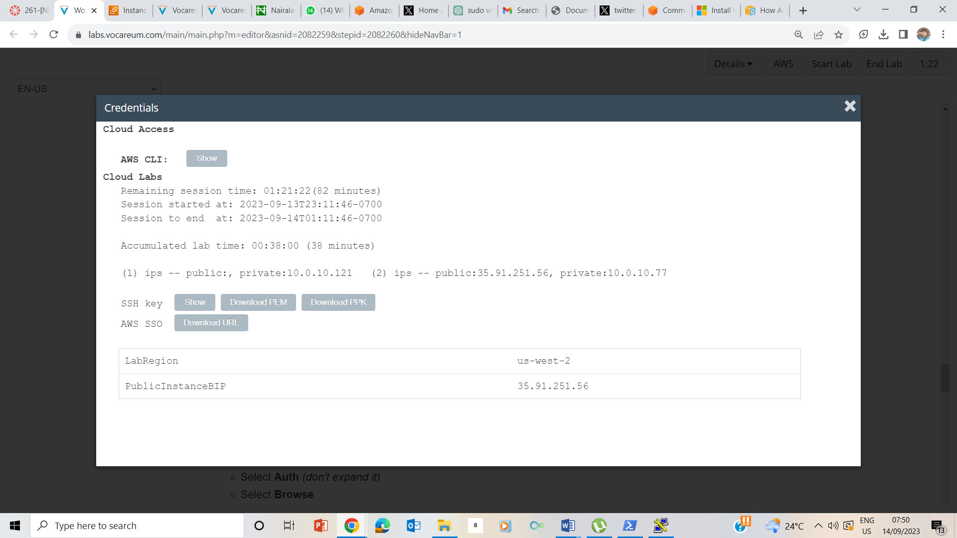

**Clicked on Details, , noted the downloaded ppk since I am using Windows OS for my labs.**

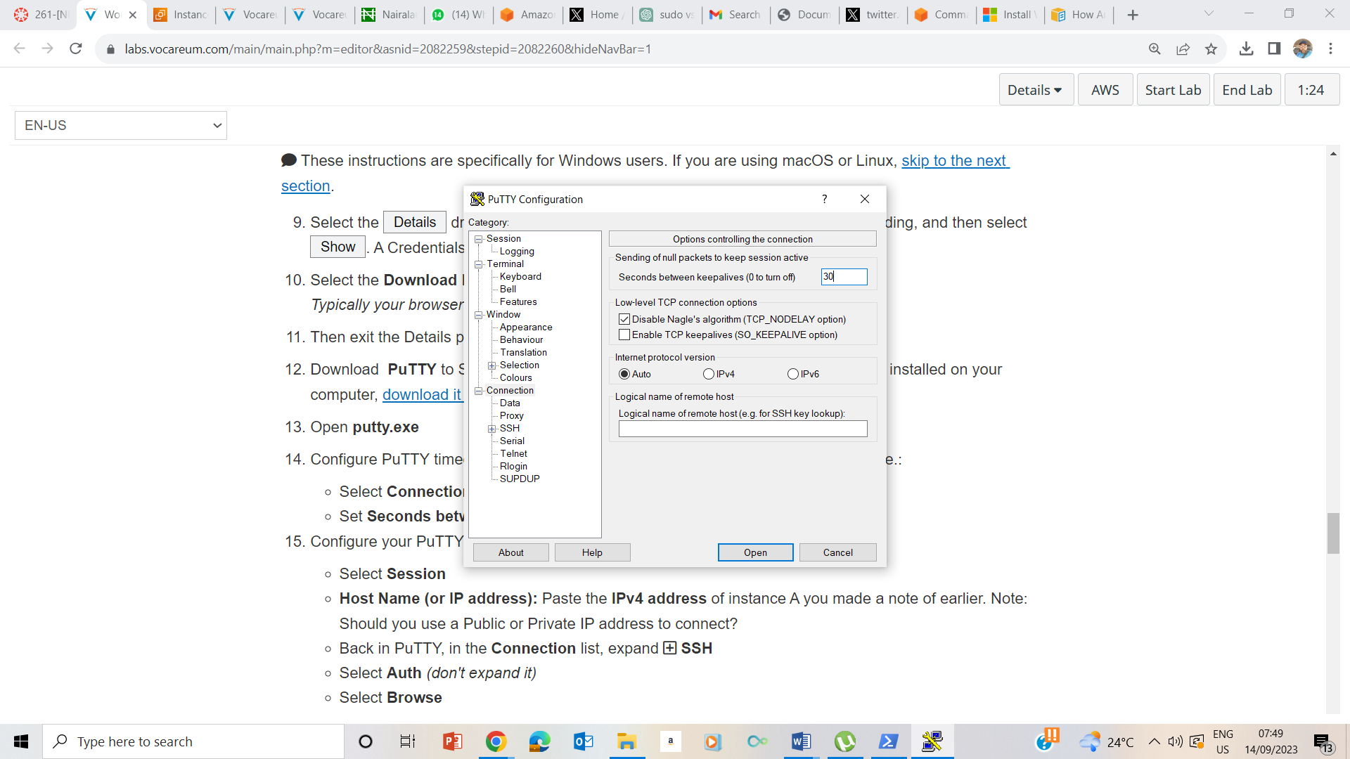

**Kept seconds alive to 30 upon clicking connection**

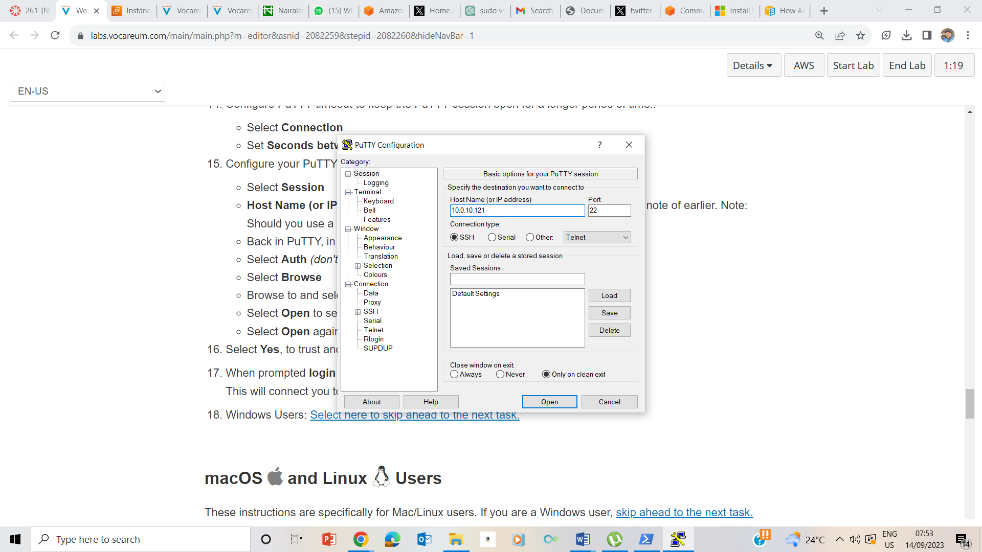

**Clicked on session , and pasted the public ipv4 address of instance B– in the**

